Contents
Overview 1
Steps to run UPL/UNMC: 1

Overview
Adhoc (State sends which quarter want ran for); similar mapping to optumas
- Comes directly from landing
- Uses quarterly data
- 4 extracts
  - Prof_header & dtl
  - Facility_header & dtl
- State sends PIN(Provider Identifier) List
  - Only providers on list go to extract
  - Claim data filtered by provider list -> extract
- Common Error:
  - DS job looking for PIN file naming convention without “_nodup.CSV” suffix, but rather end in “_CYXXX.csv”

Steps to run UPL/UNMC:
- Receive PIN Email from State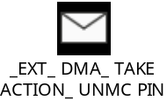
- Request Admins to move file to DS server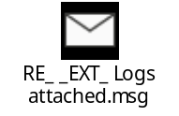
Can someone please move UNMC_Phys_Den_cmb_pin_list_Q1_CY2024_nodup.CSV file from SFTP server into /data/NE_DMA/UPL/lookup directory on Prod DS server

- Update /data/NE_DMA/scripts/input_ds_upl_prof_claim.txt. No need to change the file if running manually from Datastage.
  - Change date to first day of the last month of the quarter you're running for
    - Ex) 2024 Q1 = 2024-03-01
    - Ex) 2024 Q2 = 2024-06-01
    - Ex) 2024 Q3 = 2024-09-01
    - Ex) 2024 Q4 = 2024-12-01
- Update PIN file to match expected file format
  - PIN file location: /data/NE_DMA/UPL/lookup
  - Might need to remove "nodup" And update ".CSV" to ".csv"
  - Expected file format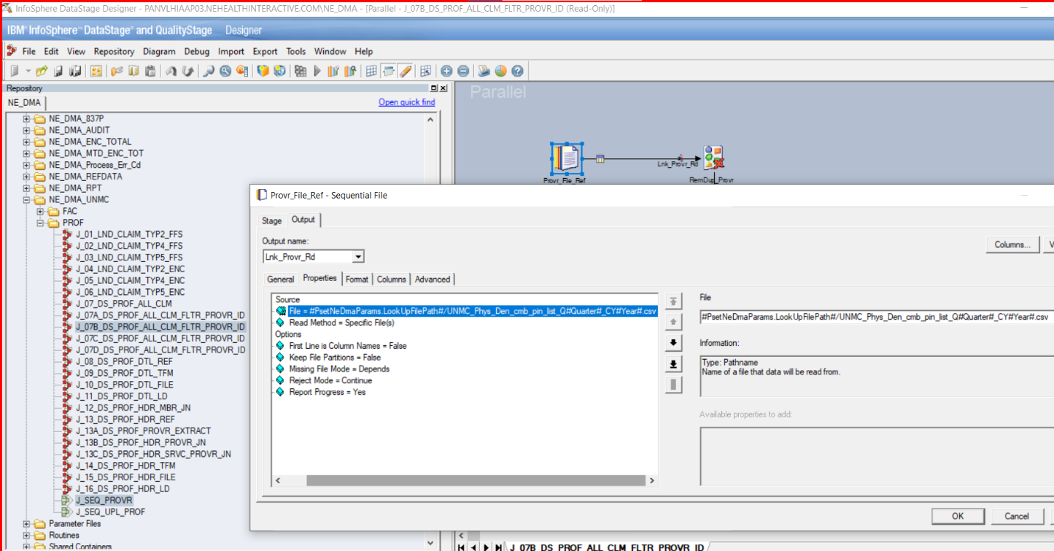
    - Only jobs that use the PIN file
    - 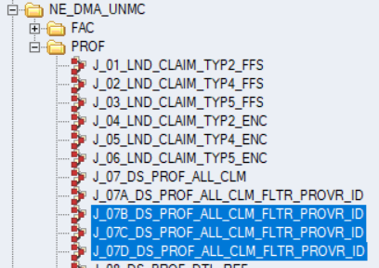

- Run J_SEQ_UPL_PROF manually in DS or schedule thru Rundeck.
Running manually from Datastage pass parameters, for example.

PsetNeDmaParams=UPL
PsetNeDmaConnection=(As pre-defined)
FILE_DATE=2026-03-01
FILE_TYPE=UPL_PROF

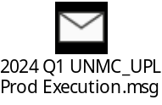

Useful Unix Files path:
/data/NE_DMA/UPL/lookup
/data/NE_DMA/UPL/out
/data/NE_DMA/scripts/input_ds_upl_prof_claim.txt

- Request admins to send zipped extract files to state server
  - /data/NE_DMA/UPL/out/UPL_ProfHdr_Extract_Q2_2025_FFS.zip
  - /data/NE_DMA/UPL/out/UPL_ProfHdr_Extract_Q2_2025_ENC.zip
  - /data/NE_DMA/UPL/out/UPL_ProfDtl_Extract_Q2_2025_FFS.zip
  - /data/NE_DMA/UPL/out/UPL_ProfDtl_Extract_Q2_2025_ENC.zip

- Archive any existing files

- After files are copied to state server email/notify State team.
